Power Rules
Zero-Exponent Rule: a⁰ = 1, this says that anything raised to the zero power is 1. | 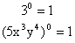
Power Rule (Powers to Powers): (a^{m})^{n} = a^{mn}, this says that to raise a power to a power you need to multiply the exponents. | 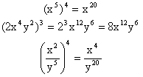
Negative Exponent Rule: 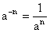, this says that negative exponents in the numerator get moved to the denominator and become positive exponents. Negative exponents in the denominator get moved to the numerator and become positive exponents. Only move the negative exponents. | 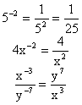
Product Rule: a^{m} ∙ a^{n} = a^{m + n}, this says that to multiply two exponents with the same base, you keep the base and add the powers. | 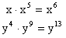
Quotient Rule: 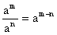, this says that to divide two exponents with the same base, you keep the base and subtract the powers | 